**Portable Solid Phase Extraction of Copper, Cadmium and Lead Using Analig ME-02 Chelating Resin and Their Determination by Atomic Absorption Spectrometry**

Mohamed Abousa Gaza1,2, Lukman Hakim2, Akhmad Sabarudin2

1Department of Chemistry, Faculty of Teacher, Tiji, Al-Jabel Al-Gharbi University, Libya Arab

2Department of Chemistry, Faculty of Science, Brawijaya University,

Jl Veteran Malang 65145 Indonesia

E-mail: gaza20052003@yahoo.com

**ABSTRACT**

The adsorption of metallic elements on the solid phase chelating resins is probably the most effective separation and preconcentration methods. In this work, portable Solid phase extraction (SPE) was constructed using a commercially available plastic syringe containing certain amount of the Analiq ME-02 chelating resin. The ability of this portable SPE was evaluated through adsorption-desorption process of copper, lead, and cadmium prior their determination by atomic absorption spectrometry (AAS). Some parameters affecting the adsorption-desorption of these heavy metal ions on the Analiq ME-02, which include effect of pH and concentration of eluent ((HNO3), were investigated in detail. It was found that quantitative adsorptions (> 90%) of copper, lead, and cadmium are obtained at all pHs (4-8) examined, whereas 1 M HNO3 was found to be effective for the desorption of these metals with the recoveries in the range of 93 -114%. Such results indicated that Analig ME-02 has excellent chelating ability (pH-independent) for the adsorption of copper, lead, and cadmium, while portable SPE system provides easiness and effectiveness for collection/preconcentation of metallic elements*.*

***Keywords :*** *Analig ME-02, heavy metals, solid phase extraction, AAS, adsorption*

1. Introduction

The analysis of trace elements in various practical complex samples in natural water, wastewater, biological, alloy, and industrial samples, is one of the most challenging areas in analytical chemistry. Some heavy metals require adequate knowledge to establish the degree of their toxicity in the environment, for examples excessive amounts of copper, cadmium and lead in the environment potentially cause adverse effects for human and animals, due to the increasing of heavy metal concentration in the environment. Their exposes to human may cause vomiting, irritation, abdomen pain, disorder of respirator system, brain, nerve system, kidney and reproductive system. Consequently, development of sensitive and reliable analytical methods are required to evaluate the impacts of metal pollutants in samples [1].

Direct determination with highly sensitive and powerful instrumental techniques is often difficult owing to matrix interferences and extremely low concentration of analyses in the samples. Accordingly, a preconcentration and/or separation procedures are frequently required to improve the detection limit of such instruments. Various methods are used for this purpose, such as co-precipitation, cloud point extraction, liquid-liquid extraction, and solid phase extraction (SPE) involving ion exchange and chelating resin, have been developed so far. Nowadays, SPE is widely used because it offers a number of important benefits: harmful solvent usage and exposure can be avoided, the procedure is simple, high concentration efficiency, and disposal cost can be reduced.

Accordingly, SPE technique is now routinely used in various researches and application over the classical solvent extraction and other preconcentration techniques.The adsorption of metallic elements on solid phase chelating resin is probably the most effective separation and preconcentration methods. Therefore, there are have been many chelating resins commercialized by some companies, i.e. Muromac A-1, Chelex 100, Amborane 345, Chelite-N, Duolite ES-467, Uteva, Diaion, MISSO ALM, and CR20 [2]. Besides chelating resin, ion exchange resin can also be used for separation, collection/concentration of trace elements.

Ion exchange resin can absorb ionic species primarily by ionic interaction based on Coulombic force, and is particularly suitable for the separation of ionic species. On the other hand, a chelating resin is well suited for carrying out the adsorption and separation of the specific ionic species, in a system with a multitude of coexisting species. Although the chelating resin resembles ion exchange resins in those ionic species are collected, the operating mechanisms are quite different. Basically, chelating resin adsorb species ions uses the chelating formed reaction by creating coordinate bonds. Therefore, the chelating resin is capable of adsorbing species ions more selective than their ion exchange counterparts [3].

Fundamentally, a chelating resin consists of two components, such as chelating moiety and the polymeric base material. The properties of both components are essential for characteristics and application of the resin. The chelating moiety is very important for designing high selectivity of the resin towards spesific analytes, whereas the base material is important for improving mechanical strength, chemical stability, adsorbed capacity, adsorpted kinetics, and reusability of the chelating resin. The polymeric support used for the immobilization of chelating moiety can be divided into inorganic and organic base materials. Inorganic base materials involve silica gel, keiselgur, controlled-pore glass, whereas organic base materials include synthetic (polystyrene, polyetheneimine, polyurethane, divinyl benzene, etc.) and natural polymer (cellulose, chitin, chitosan, etc).

The chelating moiety can be directly reacted with the trace element contained in the sample solutions, and the formed chelate is further retained on an appropriate polymeric support materials. However, complicated procedures in the application for separation and preconcentration of trace elements could not be avoided. Therefore, the introducing of chelating moiety into polymeric base material is the best choices, consisting of two strategies: (1) the chemical bonding of such moieties on existing base material (functionalized resin), and (2) the physical binding of the moieties on the base material (impregnated, coated, loaded resin). Generally, chelating moieties is attached to polymeric base materials by chemical bonding much more resistant to external effects than those immobilized by simple impregnation. The insertion of suitable specific functional groups into the polymeric support material creates them capable of reacting with metal ions or metal species under certain favorable conditions to form chelate rings.

By using the concept above, numerous chelating resins have been reported so far. Chelating moieties of 8-hydroxyquinoline [4,5], dithizone [6] , 1-(2-pyridylazo) 2-napthol [7], diethyl dithiocarbamate [8], calixarene hydroxamate [9], were immobilized on the silica-base material. Other functional moieties, such as 2,5-dimercapto-1,3,4-thiodiazole [10], pyrochatechol [11], maleic acid [12], 2-(-hydroxymethyl) benzimidazole [13], *o*-aminophenol [14], 2-napthol-3,6-disulfonic acid [15], salen [16] were chemically bonded to polystyrene-based material. To the best of our knowledge, it is very rarely reports on the use of the methacrylate-based polymeric supports for chelating resins. [17] Reported the adsorption and preconcentration of transition and rare earth elements using monolith prepared by poly-(glycidyl methacrylate/GMA-co-ethylene dimethacrylate/EDMA) functionalized with iminodiacetic acid (IDA), whereas [18] applied Analig ME-03 chelating resin for speciation of the chromium species. The latter resin is made from functionalization of IDA to the GMA-based polymeric support.

The main advantage of the GMA-based polymer in comparison to other inorganic and organic polymer supports is its inertness towards metallic elements, implying the adsorption of metal ions occurs only to the functional chelating moieties. By exploiting the merit of GMA-based on a polymeric support, in this work, a simple method for the collection/adsorption of Cd, Cu as well as Pb from aqueous samples is proposed by using the Analiq ME-02 chelating resin, which functional chelating moiety of IDA. This adsorbent is put inside a commercially syringe (portable solid phase extraction system). In regard to the quantitative adsorption-desorption process using the proposed method, some parameters including pH of sample, eluent volume and concentration (HNO3) were optimized. Atomic Absorption Spectrometry (AAS) was employed for measurement of adsorption and recovery amounts of the target metal ions.

**2. Experimental**

***2.1 Reagent and materials***

The Analiq ME-02 was donated by GL Science Co. Ltd (Tokyo, Japan). All reagents used in this experiment were of analytical grade. Stock solution (1000 ppm) of copper, cadmium, and lead were prepared by accurate dilution of CuSO4, CdCO3, and PbNO3 (Merck, Germany). Working solution of multi-elements standard solution for copper, cadmium and lead were prepared by diluting several kinds of a single elements standard from stock solution. The sample solution containing the mixed heavy metal ions were adjusted to certain pHs before the column pretreatment.

Analytical grade nitric acid (65 %, density 1.512 g/mL) from Merck (Germany) was diluted with distilled water to give a 0.5 M, 1 M, and a 2 M acid solutions as the eluents. For pH adjustment, ammonium acetate solution was prepared by mixing acetic acid (96 %) and ammonia water (29 %) purchased from Sigma Aldrich.

***2.2 Instrumentation and Apparatus***

The atomic absorption spectrophotometer (AAS) model AA-6200 (Shimadzu, Japan) was used for the measurement of copper, cadmium, and lead with the operating conditions as shown in Table 1.

Table 1. Operating condition of AAS

|  |  |  |  |  |
| --- | --- | --- | --- | --- |
| **No** | **Elements** | **Copper**  **(Cu)** | **Cadmium (Cd)** | **Lead**  **(Pb)** |
| 1 | Lamp Current (mA) | 10 | 13 | 20 |
| 2 | Fuel gas flow rate (L/min) | 1.8 | 1,8 | 2 |
| 3 | Flame Type | Air -C2H2 | Air- C2H2 | Air -C2H2 |
| 4 | Wavelength (nm) | 324,8 | 228,8 | 217,0 |
| 5 | Slit Width | 0,7 | 0,7 | 0,7 |

Portable SPE as shown in Fig. 1 was constructed using the 10-mL plastic syringe for sample loading, which is connected with the 1-mL plastic syringe as the place of Analig ME-02 (200 mg), and the T-way connector for flow rate adjustment.

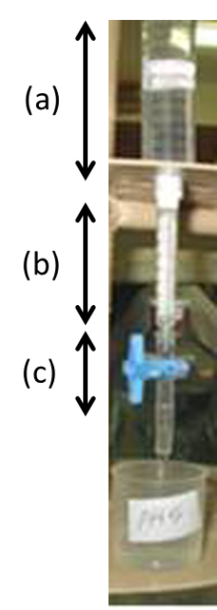

Fig 1. Laboratory-made portable solid phase extractant (portable SPE) (a) 10-mL plastic syringe, (b) 1-mL plastic syringe loaded with the Analig ME-02, (c) T-way connector

***2.3 Adsorption-desorption procedures using portable SPE***

In general, mixed metal ions (10 mL) solution containing 0.5 and 2 ppm of each Cd (II),Cu (II) and Pb(II) were adjusted at various pHs and passed through the portable SPE column. Then, the adsorbed elements were eluted with various concentration of nitric acid. The recovered mixture of metal ions was measured by AAS and their recoveries were calculated. In detail, the adsorption-desorption procedure of Cd (II),Cu (II) and Pb(II) is as follows: the Analiq ME-02, packed in the 1-ml plastic syringe, was washed with each 10-mL of 2 M nitric acid and distilled water to remove any undesired contaminant existing in the column. Then, 10-mL of 0.5 M ammonium acetate buffer solution (pH 4-8) was passed through the column for conditioning the portable SPE. Subsequently, a mixed sample solution (10 mL) containing Cd (II), Cu (II) and Pb(II) (10 mL), whose pH was adjusted, was passed through the column. A 10-mL of distilled water was then passed through the column to wash out remaining un-adsorbed analytes. Finally, 10-mL aliquot of various concentration of nitric acid (0.5, 1, and 2 M) was passed through the column to examine the recoveries efficiency of the adsorbed elements. All eluates were measured by AAS according to the conditions given in Table 1. Throughout the column pretreatment, the flow rate of the sample, and other solutions was fixed at about 0.5 mL/min. The adsorption amount (equation 1) and recovery (equation 2) of metal ions was calculated as follows:

 …………… (Eq.1)

Where: C means concentration after adsorption

C0 means initial concentration (original)



…………… (Eq.2)

Where:

*n*eluent : the amount of target metal recovered in eluent (ppm)

*n*sample : the initial amount of metal in sample (ppm)

**3. Result and Discussion**

***3.1 Effect of pH for the adsorption of metal ions on the Analig ME-02***

The pH of sample is one of the most factors affecting the adsorption/ preconcentration of copper (II), cadmium (II), and lead (II) on the column. The acidity of sample was varied from pH 4 to pH 8 by adjusting the mixed-sample solution with ammonium acetate solution. As given in Fig 2, the Analig ME-02 can adsorb all target metal ions almost completely (100%), showing excellent ability of this adsorbent at various pHs without any loss of efficiency. This result also indicates that the adsorbent used in this experiment is suitable for multi-elemental adsorption, which can further applied for removal of heavy metal ions from a very complex matrix samples i.e wastewater. It also should be noted that no loss of the activity and efficiency of the adsorption behavior toward metal ions after prolonged usage (> 50 cycles) is the addition advantages of this adsorbent.

Although the Analig ME-02 chelating adsorbent can adsorb heavy metal ions at wide range pHs, howewer, it is not recommended to employ this sorbent at high pH (≥ 7) since some elements may retained on the adsorbent without any interaction due to the formation of insoluble hydroxide species of the metal ion samples. Accordingly, pH ≤ 6 is preferred to avoid any precipitation during sample preparation because the solubility product constants (Ksp) of Cu(OH)2, Cd(OH)2, and Pb(OH)2 are very small. Ksp of copper, cadmium, and lead in form of hydroxide species is 1.6 x 10-19, 2.5 x 10-14, and 1.2 x 10-15, respectively.

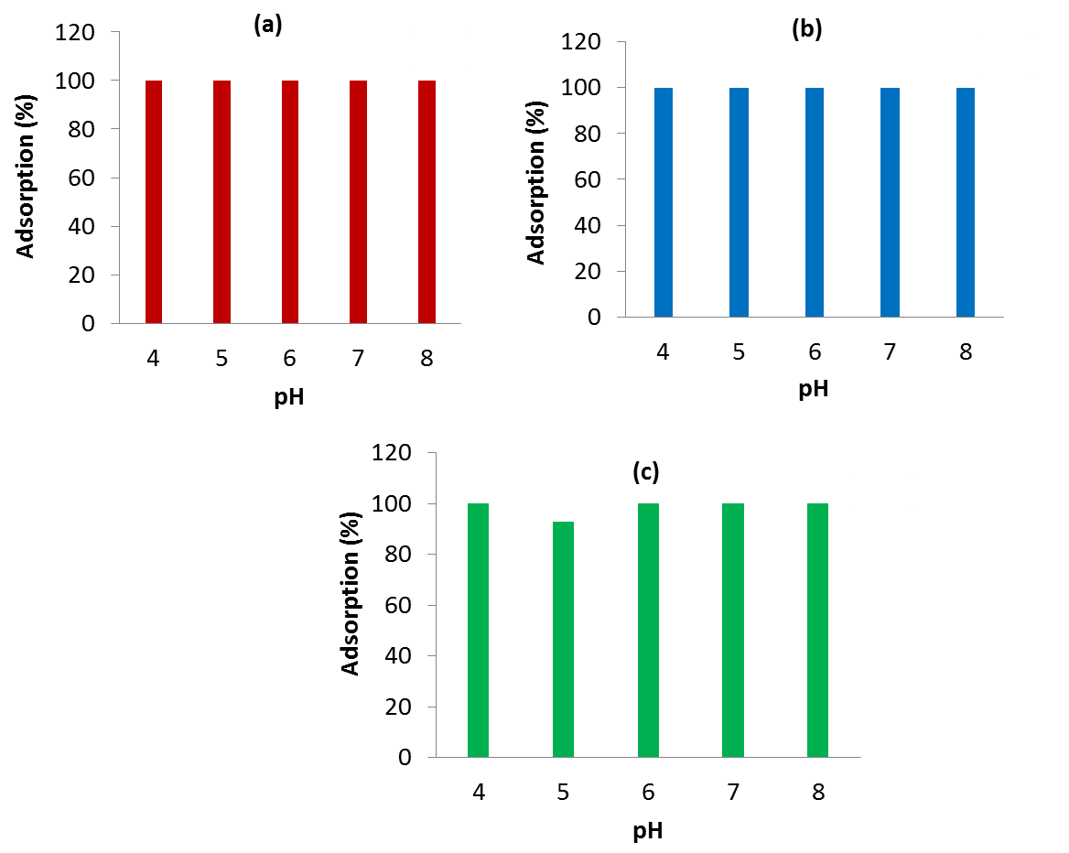

Fig 2. Effect of pH for the adsorption of copper (a), cadmium (b), and lead (c) on the Analig ME-02

***3.2 Adsorption mechanism of Cd, Cu and Pb on the Analig ME-02***

The Analig ME-02 chelating adsorbent possesses the functional moiety of iminodiacetic acid, HN(CH2CO2H)2 ) (IDA). In the range of pH 4-8, IDA exists in the form of a single negatively-charged ion of its carboxyl group (COO-). Since the metal ions are positively-charged, it is possible that Cu(II), Cd(II), and Pb(II) may adsorb on the adsorbent by the ion-exchange mechanism or electrostatic interaction. Typically, this bonding is easily broken up by eluting with a low concentration of mineral acid (≤ 0.2 M). However, in our experiment, the adsorbed metal ions on the Analig ME-02 can be eluted quantitatively (≥ 93%) with at least 1 M HNO3, indicating strong binding ability of the IDA functional moiety toward metal ions. Accordingly, we propose chelating mechanism that may responsible for the adsorption of Cu(II), Cd (II), and Pb (II) on the Analig ME-02 as illustrated in Fig. 3. Chelating mechanism is the formation of two or more separate coordinate bounds between a polymer ligand and a single central atom. In comparison to an ion exchange counterpart, the ligand affects to the enhancement affinity of chelating adsorbent towards metal ions. In our experiment, the chelation of Cu(II), Cd(II), and Pb(II) occurs via the neighboring carboxyl groups (COOH) of IDA moiety under the formation of a six-membered ring.



Fig. 3 Proposed adsorption mechanism of Cd, Cu and Pb on the Analig ME-02

***3.3 Effect of Eluent concentration on the recovery of Cu, Cd, and Pb***

Nitric acid (HNO3) was used as an eluent for the present study. Several factors affecting the elution efficiency of analytes, such as an eluent concentration, and an eluent volume were studied. The concentration of HNO3 on the elution of analytes adsorbed on the portable SPE column containing the Analig ME-02 was examined in the ranges of 0.5-2.0 M as shown in Fig 4. It was found that 0.5 M HNO3 was not sufficient to elute analytes quantitatively especially for Cd, which indicated by its recovery of about 78%. In this condition, Cu could be recovered almost completely (89%), while recovery of Pb is found to be 106%. Therefore, we speculated that binding/chelating ability of metal ions on the Analig ME-02 is in the following order: Pb < Cd < Cu. As also shown in Fig 4, all metal ions can be eluted completely when 1 M HNO3 was used. Similar result was also found in case of 2 M HNO3 was applied as the eluent. From these results, a 1 M HNO3 was chosen as an optimal eluent concentration as compromise to the recovery values, reagent consumption, and environmental impact. The reaction recovery mechanism is illustrated in the Fig 5.

The volume of eluent (1 M HNO3) was examined by varying its volume from 5 to 15 mL to ascertain the complete elution of the analytes. The results showed that no significant differences of all volume examined with the recoveries of metal ions in the range of 90 – 114%. Although a 5-mL of HNO3 is enough for elution, however it is too close to the volume required for AAS measurement. By considering this reason, and also the need of lowest volume possible to obtain the highest enrichment factor, a 10-mL of HNO3 was selected for the optimal volume of eluent.

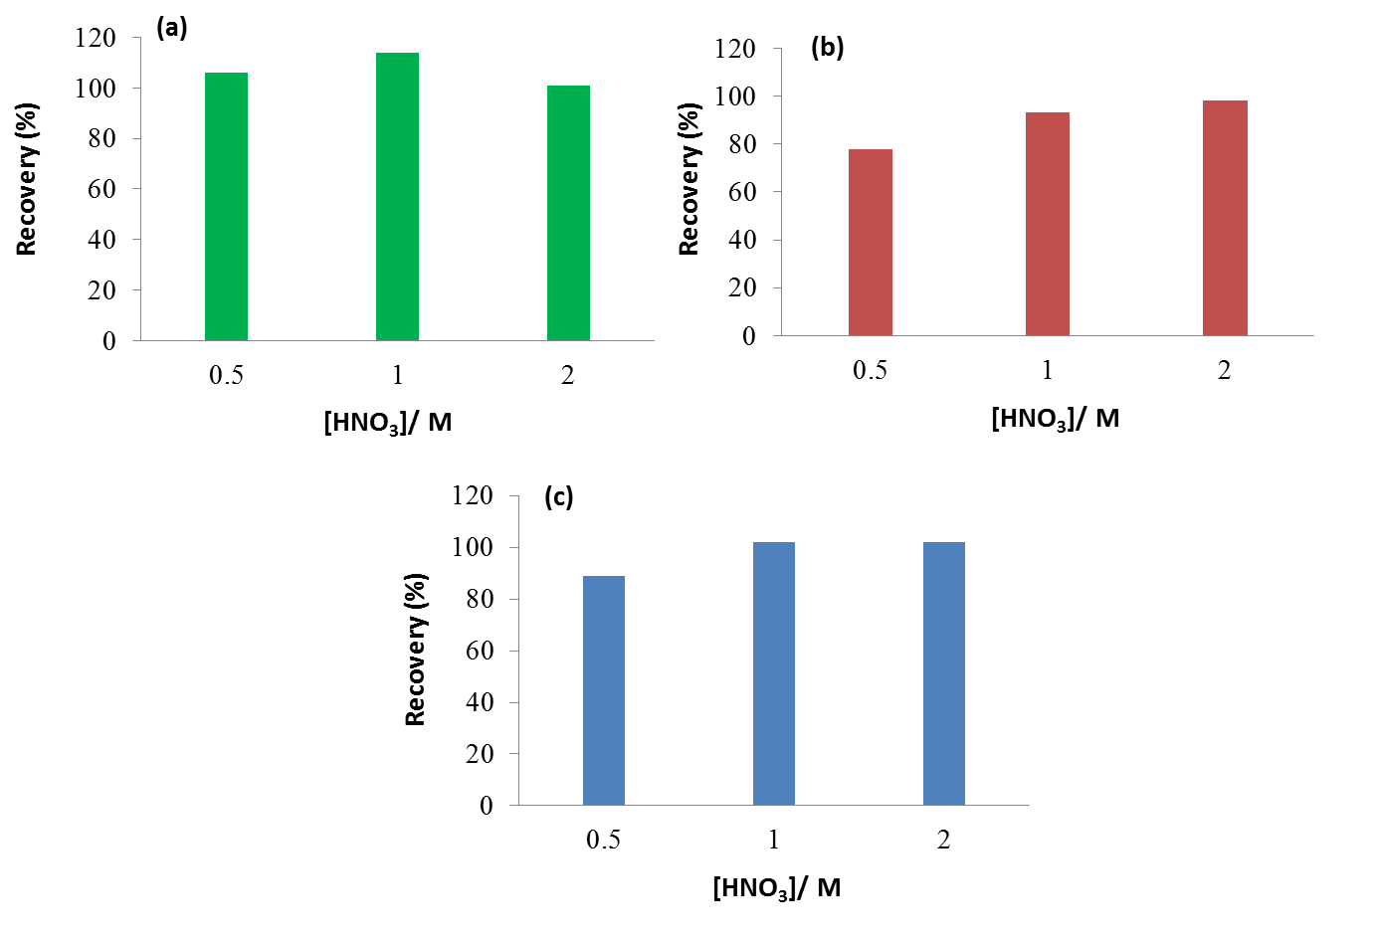

Fig. 4 Recovery of copper (a), cadmium (b), and lead (c) at various nitric acid concentration



Fig. 5 Reaction recovery mechanism of metal ions

**4. Conclusion**

Portable solid phase extraction containing the Analig ME-02 chelating developed in this work provides excellent adsorption of heavy metal ions at wide range pHs with no loss of the activity and efficiency of the chelating ability after prolonged usage. It is possible that the proposed method can be further applied for collection/preconcentration of multi-existing ion in a very complex matrix solution. All adsorbed metal ions in the column could be recovered completely using 1 M nitric acid.

**Acknowledgements**

I would like to say Thank you, for the Faculty of Teachers Tiji, Al-Jabel Al-Gharbi University Libya Arab financial support (scholarship), studying Master chemistry in the extraction of heavy metals from water, as well as thank for supervisor and co supervisor support me when I study in University Brawijaya Malang Indonesia.

**References**

[1] Chalapathi, K and Maddaiah, G. P, ***2010*,** Solid phase extraction of Copper, Cadmium and Lead in environment sample FAASusing activated carbon modified with 5-(4 dimethyl Iminobenzyledememino)-2hydroxy benzoic acid, Journal of Chemical and Pharmaceutical research. 2(2).

[2] Agarwala, B.V. and Munshi, K.N, ***1993*,** Facets of Coordination Chemister, Book, published by world Scientific. p. 123.

[3] Sabarudin, A; Lenghor, N; Oshima, M; Hakim, L; Takayanagi, T; Gao, Y; Motomizu, ***2007***, Sequential-injection on-line perconcentration using chitosan resin functionalized with 2-amino-5hydroxy benzoic acid for the determination of trace elements in environmental water sample by inductively coupled plasma-atomic emission spectromatery, Talanta Vol72 (2007) page 1609-1617

[4] Sohrin, Y., S.-I. Iwamoto, S. Akiyama, T. Fujita, T. Kugii, H. Obata, E. Nakayama, S. Goda, Y. Fujishima, H. Hasegawa, K. Ueda, M. Matsui, Anal Chim, ***1998***, Determination of trace elements in seawater by fluorinated metal alkoxide glass-immobilized 8-hydroxyquinoline concentration and high-resolution inductively coupled plasma mass spectrometry detection Acta, 363 p. 11-19

[5] Halicz, L., I. Gavrieli, E. Dorfman, ***1996***, On-line method for inductively coupled plasma mass spectrometric determination of rare earth elements in highly saline brines J. Anal. At. Spectrom., 11 , 811-814 .

[6] Mahmoud, M. E., M.M. Osman, M.E, ***2000***, Selective pre-concentration and solid phase extraction of mercury (II) from natural water by Silica gel-looded dithizone phase, Amer, Anal. Chim. Acta 415, 33

[7] Maurya, M. R., S. Sikarwar, T. Joseph, P. Manikandan, S. B. Halligudi, ***2005***, Synthesis, characterization and catalytic potential of polymer-anchored copper(II), oxovanadium (IV) and dioxomolybdenum (VI) complexes of 2-(hydroxymethyl) benzimidazole, React. Funct. Polym., 63, 71 .

[8] Karami H., M. F. Mousavi, Y. Yamini, M. Shamsipur, ***2004***,On-line preconcentration and simultaneous determination of heavy metal ions by inductively coupled plasma-atomic emission spectrometry Anal, Chim. Acta. 89, p. 509.

[9] Garcia, A. R, A. Hrdlicka, J. Perutka, J. Havel, N.V. Deorkard, L.L. Tavlarides, M. Munoz, M. Valiente, ***2001***, Separation of rare earth elements by high performance liquid chromatography using a covalent modified silica gel colum, Anal. Chim. Acta 439, 247.

[10] Qu, R., C. Sun, C. Ji, C. Wang, Z. Zhao, D. Yu, ***2005***, Synthesis and adsorption properties of macroporous cross-linked polystyrene that contains an immobilizing 2,5-dimercapto-1,3,4-thiodiazole with tetraethylene glycol spacers, Polym Eng. Sci., 45 P. 1515.

[11] Tewari, P. K., A. K. Singh, ***2001***, Synthesis, characterization and applications of pyrocatechol modified amberlite XAD-2 resin for preconcentration and determination of metal ions in water samples by flame atomic absorption spectrometry (FAAS) Talanta, 53, 823.

[12] Rahman, Yoshiaki, Furusho, Sabarudin, ***2011***, Separation of Lead from high matrix electroless Nikel plating waste solution using an Ion-Selective immobilized.

[13] Maurya, M. R., S. Sikarwar, T. Joseph, P. Manikandan, S. B. Halligudi, ***2005***, Synthesis, characterization and catalytic potential of polymer-anchored copper(II), oxovanadium (IV) and dioxomolybdenum (VI) complexes.

[14] Kumar, M., D. P. S. Rathore, A. K. Singh, ***2000***, Amberlite XAD-2 functionalized with *o*-aminophenol: synthesis and applications as extractant for copper(II), cobalt(II), cadmium(II), nickel(II), zinc(II) and lead(II), Talanta, 51 p. 1187

[15] Mondal, B.C., D. Das, A. K. Das, Talanta, ***2002***, Synthesis and characterization of a new resin functionalized with 2-naphthol-3,6-disulfonic acid and its application for the speciation of chromium in natural water 56 p. 145

[16] Qu, R., C. Sun, C. Ji, C. Wang, Z. Zhao, D. Yu, ***2005***, Synthesis and adsorption properties of macroporous cross-linked polystyrene that contains an immobilizing 2,5-dimercapto-1,3,4-thiodiazole with tetraethylene glycol spacers, Polym Eng. Sci., 45 P. 1515.

[17] Dwinna Rahmi, Yuka Takasaki, Yanbei Zhu, Hiroharu Kobayashi, Shigeji Konagaya, Hiroki Haraguchi, Tomonari Umemura, ***2010***, [Preparation of monolithic chelating adsorbent inside a syringe filter tip for solid phase microextraction of trace elements in natural water prior to their determination by ICP-MS](http://www.sciencedirect.com/science/article/pii/S0039914010001633), Talanta, 81, P. 1438-1445.

[18] Furusho, Sabarudin, Hakim, L., K Oshita, M Oshima, S Motomizu, ***2009***, [Automated pretreatment system for the speciation of Cr (III) and Cr (VI) using dual Mini-Columns packed with newly synthesized chitosan resin and ME-03resin](http://scholar.google.com/citations?view_op=view_citation&hl=en&user=XRBQeiUAAAAJ&citation_for_view=XRBQeiUAAAAJ:YsMSGLbcyi4C) Analytical Sciences 25 p. 51-56.